**Outputs of all the program:**

1. Write a program to Swap to two numbers(Output)

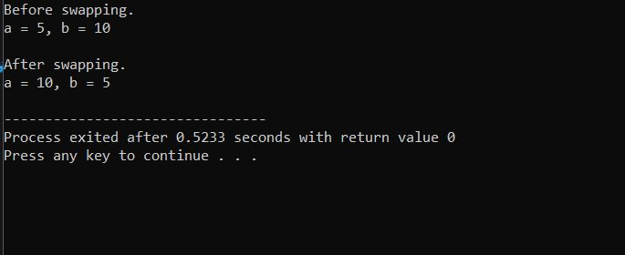

2. Write a program to find the largest number among three numbers entered by the user(Output)

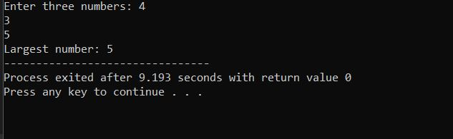

3. Write a program to check whether a year entered by a user is Leap year or not(Output)

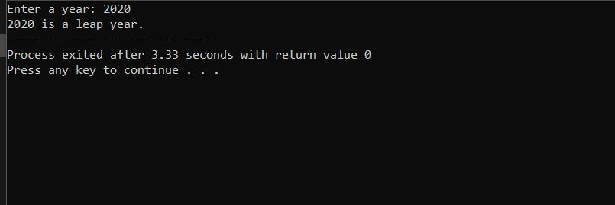

4. Write a program to display Fibonacci Series upto nth term. (Using loops)(Output)

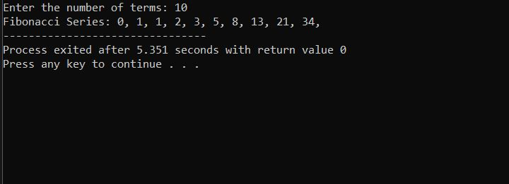

5. Write a program to check whether a number is Prime or Not(Output)

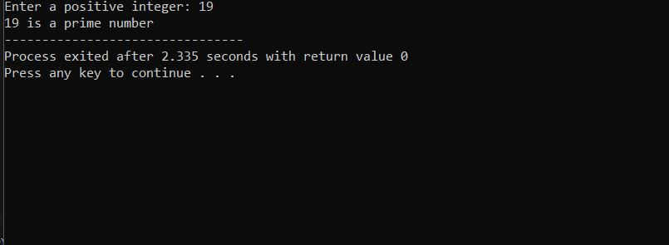

6. Program to print full pyramid using star(Output)

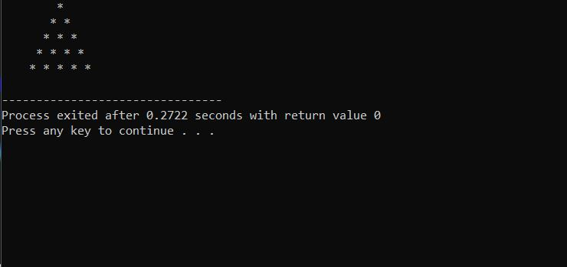

7. Write a program that takes n elements from the user and displays the second largest element of an array(Output)

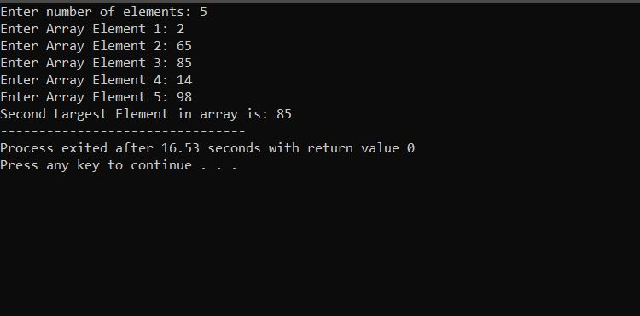

8. Left rotation(Output)

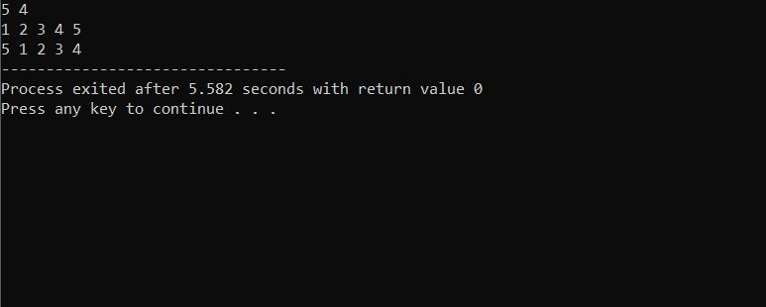

9. Grading Students(Output)

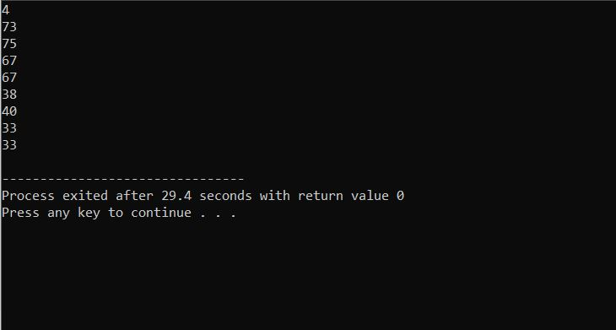

10. CamelCase(Output)

